EE422C Project 5 (Critters 2) **README**

Marcus (Yilin) Zhu, *yz22778*

Andrew Wong, aw27772

Git URL: https://github.com/Marcus-Zhu/EE422C_HW4_Critter/

Fall 2016

This README covers the following topics:

1. **A description of your code and graphics, and it might include diagrams.**

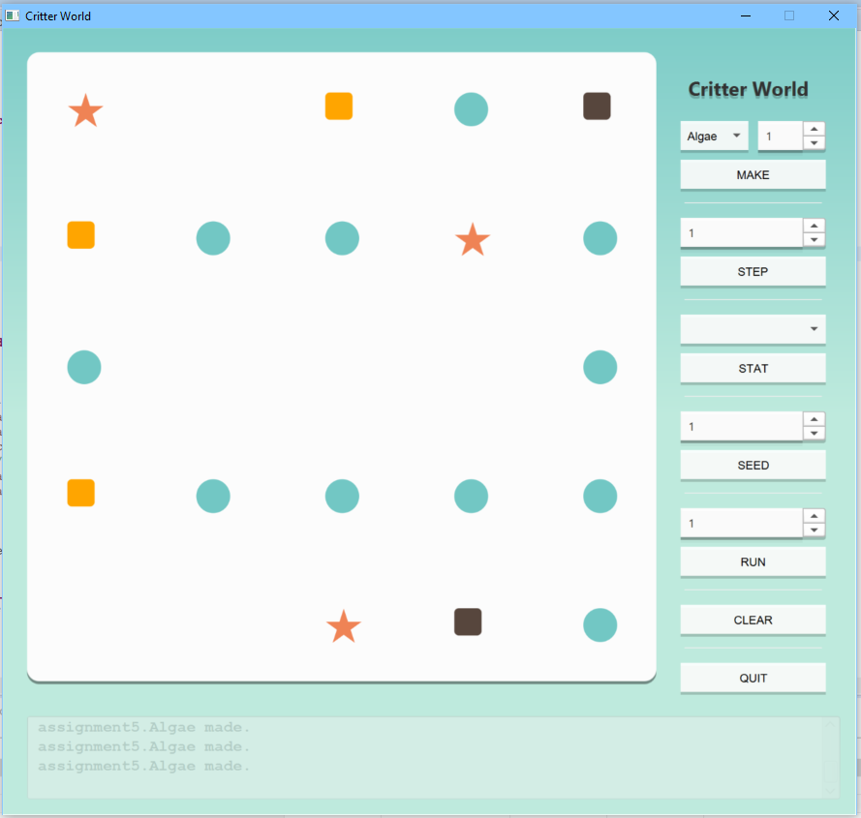

**Figure 1. A screenshot of the GUI**

Our graphical user interface (GUI) consists of a visual representation of the critter world on the left, and user controls on the right. Additionally, the GUI includes a console on the bottom of the window. The critter world is a 5 x 5 grid populated with colored shapes that represent different critter types. For example, myCritter1 type critter is represented by a purple diamond. The user controls consists of make, step, seed, run, clear, and quit buttons. The make button creates a new critter of the user specified type, and places the critter at a random spot in the critter world. The step button runs the world simulation for a specified number of steps. The seed button sets the world seed. The run button runs the world simulation continuously, and the user can specify how many steps to run per second. For instance, if the user selects “1,” the simulation runs at 1 step per second. The clear and quit button clear the critter world and exit the program, respectively.

**2) Any feature in your project implementation that you think is usually good, or did not meet the standard. Briefly describe any problem that you had and could not solve.**

Our project utilizes a clear and concise GUI, and implements a uniform design across the entire GUI. The GUI has a logical layout, with all buttons grouped in a common area and each button appears roughly in the order the user would click on them. For example, the user would probably first create critters, so the “make” button is located at the top. Likewise, the “Exit” button is at the bottom of the window. Additionally, the GUI and critters use colors that complement each other.

We believe that our project meets the lab specifications. Also, we did not encounter any problems that were unsolvable during the lab.